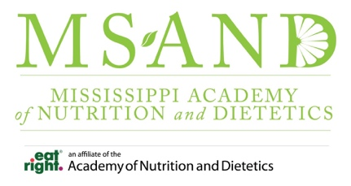

Agenda for MS-AND Article Reading Group Meeting
Date: 03/16/2026 12:00–1:00 PM
Meeting ID: 825 8673 9471
Passcode: 386387
Zoom Link: Click Here to join or copy and paste this uniform resource location (URL) https://eatright-org.zoom.us/j/88228548414?pwd=3bFQerbfeGYR1iQucfHpQpx0nTHzrj.1
Time | Agenda Item | Presenters | Outcome
12:00-12:10 PM | 1.1 Introductions  1.2 Housekeeping |  | Open the meeting and outline the meeting.
12:10-12:45 PM | 2.1 Group discussion  2.1.1 Describe RD or International Equivalent efficiency in weight management interventions |  | Summarize article’s main points.
12:45-1:00 PM | 3.1 Wrap-up |  | Explain the process for claiming CPE and end meeting.
Important Information:
- MS-AND Members Private Facebook Group: https://www.facebook.com/groups/1297072291458116
- Journal of the Academy of Nutrition and Dietetics (JAND) Continuing Professional Education (CPE) Articles List: https://www.jandonline.org/content/cpe
- JAND CPE Activity Site: https://secure.eatright.org/v14pgmlib/prd/jcpe010.html
- To receive credit for reading the JAND CPE article, follow these steps:
- Login to the JAND CPE Activity Site.
- Click on the box that reads “Select available additional journal quizzes” at the top of the “Completed Journal Quizzes” page
- Click on the word “Select” next to the entry for the article you read and follow the instructions.
- Then login to myCDR to record your activity by entering the 6-digit prior approval number on the certificate of completion received after completing the JAND CPE article quiz.

